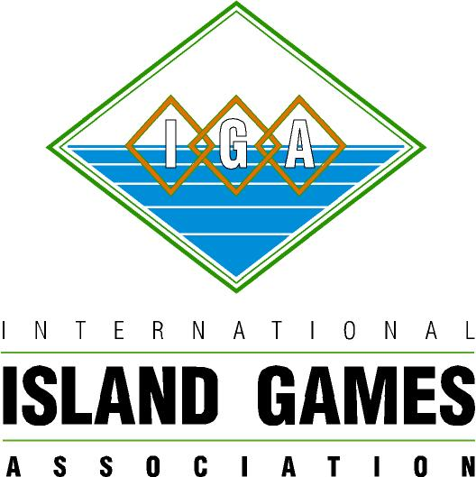

NatWest Sports Development Programme.

Application for Grant Assistance

Please tick which of the NatWest Sports Development Programme categories listed below you are applying under:

1 Coaching Development ( )
2 Sports Development ( )
3 Technical Official Development ( )
4 Travel Assistance ( )

Name of Member Island

Sport(s) to be assisted

Name of Island’s Association(s)
responsible for administering this /
these sport(s)

Person responsible for the scheme

Name

Address

Contact telephone no

E-Mail

Position

Qualifications and / or
experience within the sport

Please give a brief description of the Scheme/Project

Proposed dates

Duration

Specific venues to be used (if any):

Age range of participants

Number of participants

Equipment to be used

What do you hope to achieve by running this scheme and what would be the benefits to your Island sport (s)?

Details of any previous assistance received under the NatWest Sports Development Programme

Has the Sport received any other financial support in the last two years?

If yes, please give details:

Have similar programmes for this Sport operated before on the Island?

If yes, please give details

FINANCIAL BREAKDOWN OF PROJECT

All details to be provided in pounds sterling only, please describe details of project costs including:

Cost of facility hire £

Equipment hire £

Other Expenses - Listed individually with description £

e.g. travel, accommodation

Total cost of project £

Sources of funding for the project £

Other public funds £

Own Contribution £

Sponsorship £

NatWest Island Games grant requested £

Any additional information you wish to include

To the best of our knowledge the information provided is correct

Signed by:

Scheme Organiser
Date

The application MUST be counter-signed by either the Chairman or Secretary of your Local Island Games Association confirming their support.
Signed by:

Chairman / Secretary of Local IGA Association (delete as appropriate)

Terms and Conditions

There will be a maximum of £2,000 granted to each Island per calendar year to ensure that the total fund is distributed as fairly as possible throughout the Member Islands.

The Application should be returned to:

International Island Games Association
Goldie House 2nd Floor, 1 - 4 Goldie Terrace,
Douglas, Isle of Man IM 1EB
Tel and Fax number 00441624613344

Official use only

Application reference ………………………………

Amount of grant approved and date ………………………………

Signed ………………………….

